Woodlands Primary Behaviour Curriculum

Intent

Respect | - Understanding that we are all equally important  - Being polite and demonstrating good manners  - Treating others as we would wish to be treated  - Looking after our school and our equipment
Responsibility | - Being ready to learn and always trying our hardest  - Being honest about our actions  - Understanding that what we do affects others  - Knowing how we can look after our world
Resilience | - Finding the courage to persevere when things are tricky  - Understanding that making mistakes is part of learning  - Working through ups and downs in our relationships  - Being happy for others when things do not go our way
Care | - Always choosing to be kind  - Helping others when they need us  - Celebrating our differences  - Speaking out to keep me and others safe
Creativity | - Finding ways to express my thoughts and feelings  - Thinking in different ways to help solve problems  - Having the confidence to be original  - Enjoying and seeking opportunities to try new things
Community | - Being proud to belong to the Woodlands community  - Looking for ways to make a positive difference every day  - Bringing happiness and care to people in our wider community  - Working together to achieve greater things for everyone
At Woodlands Primary School, we develop children’s character through our behaviour curriculum. It has been developed in conjunction with our values, ethos, behaviour policy and teaching and learning policy.

We are committed to creating an environment where exemplary behaviour is at the heart of productive learning. Everyone is expected to maintain the highest standards of personal conduct, to accept responsibility for their behaviour and encourage others to do the same. We want to teach our pupils to grow into respectful, responsible and resilient adults.

We believe that as pupils practise these behaviours, over time they become automatic routines that positively shape how they feel about themselves and how other people perceive them.

Our school values below underpin the behaviour curriculum at Woodlands. Our Woodlands Way behaviour blueprint (see appendix A) is a central pillar of our behaviour curriculum, with our three key rules: Be ready, be respecful, be safe. An overview can be found in Appendix B.

Explicit teaching of behaviour curriculum at key points in the school year and ongoing
Explicit spotlight on key areas of behaviour curriculum and expectation in assemblies

Schemes of work in PSHE that cover elements of the behaviour curriculum
Woodlands Behaviour Curriculum
Routines and expectations for all – embedded within teaching and learning policy, including ‘Walkthru’ focus

School values and behaviour policy
Commitment to teacher and teaching assistant ongoing professional development in understanding and supporting behaviour

Implementation
Behaviour expectations are taught explicitly during the first week of the autumn term alongside the Woodlands Curriculum. This happens in classrooms, in assemblies, in the playground and across all school spaces. At the start of each term, the behaviour expectations are revisited with pupils and continue to be reinforced throughout the year. As with other curriculum content, this is taught using explicit teaching. Our teachers also demonstrate these behaviours and ensure children have time to practise. For example, our lining up routine is taught in the classroom but reinforced in different locations and times throughout the school day e.g. at lunchtime. It is expected that all children know this content. It is expected that all adults and pupils will know and demonstrate the behaviour expectations in all areas of school including the playgrounds, dining halls and corridors.
Through our Behaviour Curriculum, we teach outstanding behaviour through clear expectations, routines and opportunities for all staff and children to rehearse, model and refine these behaviours. We want our children to understand how and why we behave and to have frequent opportunities to practise doing so, in order for these behaviours to become intrinsic in their day to day lives. Our Behaviour Curriculum is designed to be accessible for children from Reception to Year 6 and curriculum adjustments are made to suit the needs of all children including those with SEND and other additional needs – we want every child to have the best chance of success.
Continuous professional development for teachers and teaching assistants
INSET training sessions are used frequently to explicitly teach behaviour management e.g. focus time on behaviour policy and Walkthrus (pedagogical approach). Weekly briefings allow an opportunity to direct and support staff on managing and supporting behaviour across all elements of school life. All staff have access to National College, an online CPD provider that has behaviour specific training. All staff undertake a rigorous induction process that includes input on the behaviour policy. Early Career Teachers are supported by mentors to develop behaviour management strategies and ensure explicit teaching and modelling of behaviour expectations.
Collaboration with Parents
The school encourages opportunities to work collaboratively with parents to support behaviour. This may be specific information-sharing on the behaviour policy, on Zones of Regulation or on strategies to support a specific area of need, such as anxiety or ADHD.
Opportunities to further practise and embed elements of our behaviour curriculum are regularly met in the work school does with School Council, Eco Reps, House Captains and Playground Sports Leaders.
All children are expected to participate in the behaviour curriculum. However, adjustments can be made for pupils with SEND, e.g. use of visuals or over-learning opportunities.
At Woodlands, we recognise good behaviour, effort and conduct in the following ways:

Focus | Praise Method | Approach
Learning and Effort | House Points | For effort and successes in their learning.  1 House Point – good effort / achievement  2 House Points– outstanding effort / achievement  Teachers to determine the system for recording house points in the classroom. These will be collected weekly by year 6 monitors and celebrated in Friday’s Celebration Assembly.
Learning  Attitudes | Endeavour Award | These awards will celebrate efforts / achievements in learning. They should focus on the learning power descriptors set out on the certificates. Teachers will write the certificate and bring it to the assembly on Friday and read it aloud. To be written in the second person to address their achievements. Teachers can give more than one certificate each week.
Learning and Achievement | Weekly Celebration Assembly | Friday at 2.45pm for EYFS/KS1 and KS2.  Teachers will read Endeavour Awards to the children and explain the learning / achievement, etc.  House point weekly totals will be celebrated.  Any other recognitions will be celebrated, including sporting achievements.
Values and Behaviours | Recognition Board | In classrooms, teachers will create recognition boards with a focus on a particular desirable behaviour relevant at that time to that class. Children who demonstrate the targeted positive behaviour will have their name displayed on the board. It is expected that the focus of these will change during the term in response to pupils’ behaviour.
Values and Behaviours | Positive Postcard | These will focus on pupils going ‘over and above’ in terms of the school’s values and their behaviours over the course of the week. They will be taken home by the child at the end of the day. There is no expectation on the number to be given out by teachers. Teachers will decide how these are handed out dependent on the pupil. Teachers to have a pile of postcards accessible in the classroom for cover teachers. Visitors will also be given them for when they recognise ‘over and above’ behaviour.
Values and Behaviours | Woodlands Ambassadors | These termly awards, in the form of a letter home, will recognise pupils who consistently demonstrate the school’s core values: respect, responsibility, resilience, care, creativity and community. These will be handed out in the last celebration assembly of each term (6 a year).
Learning, Attitudes, Values and Behaviours | Positive Phone Calls Home | Any member of staff is encouraged to call the parent/carer of a child to celebrate success at any time, especially when improvement over time has been recognised.

We explicitly teach and model our key school rules. We expect every child to know and uphold that there are three behaviour expectations in school. These are to:
- be ready
- be respectful
- be safe

Children know the following examples of these three principles –
Be Ready
- Be ready to learn by showing good listening
- Walk quietly into school
- Complete homework on time
- Remember to bring equipment to school
- Wearing correct school uniform
- Sit quietly in assembly, listening and reflecting
- Tidy up your own workspace and the classroom
Be Respectful
- Say ‘please’ and ‘thank you’
- Hold doors open for people
- Talk kindly to other pupils
- Listen to others
- Say ‘good morning/afternoon’ to adults and peers
- Appreciate others’ right to learn
- Look after school property
- Use a calm and polite tone of voice
- Value differences
- Follow teacher instruction
Be Safe
- Always choose to be kind
- Help others when they need us
- Speak out to keep me and others safe
- Sit sensibly in the classroom, with chair legs on the floor
- Walk through corridors and around school
- Play games that do not become too physical
- Use equipment as it is meant to be used
Relentless Routines
Wonderful Walking Legendary Lining-Up Heroic Hands-Up Terrific Transitions
All staff at Woodlands are committed to established and maintaining clear expectations and behaviour around key routines.
Wonderful Walking

Children know that we walk around school using ‘Wonderful Walking’

This means:
- Facing forward
- Walking in a straight line
- Hands by side
- Without talking
- Without leaning on walls whilst waiting

We use Wonderful Walking to keep everyone safe in school and to make sure the learning of other children is not disrupted as people move around school.

Legendary Lining Up
Children know that we do ‘Legendary Lining-Up’ to leave the classroom, before entering the school after break and in the dinner hall.
This means:
- Facing forward
- Sensible distance away from person in front
- Hands by side
- Ready to go
- Without talking
- Without leaning on walls whilst waiting

We use Legendary Lining-Up to ensure children are ready for their next session and so that staff can count or do the register quickly.

Heroic Hands Up
Children know that we use ‘Heroic Hands-Up’ when a member of staff raises their hand, in any location around school.
This means:
- All staff use a raised hand to signal that a group or class of children needs to stop and give attention
- Children respond by pausing what they are doing, raising their own hand in silence and facing the adult and await next steps
We use Heroic Hands-Up to gain attention quickly and prevent the need for raised voices.

Terrific Transitions
Children know that ‘Terrific Transition’ will be used within a lesson and at the end of a lesson.

This means:
  - Knowing that when the teacher signals (1) I should stop what I am doing.
  - Knowing that when the teacher signals (2) I should tuck my chair in if seated and stand up if sat down.
  - Knowing that when the teacher signals (3) I should move to my table/line up.
  - Knowing that when I am lining up, I should be quiet.

We use Terrific Transitions to ensure the learning environment remains calm and lessons start promptly and with good order.

Other routines and expectations are laid out below:

Arriving at school at the beginning of the day

- Know that I arrive on time to school
- Know that I walk calmly to our classrooms
- Know that I greet staff, children and visitors with a smile and a ‘good morning’
- Know that I hang my coat up, put my lunchboxes away tidily and water bottle in its allocated place
- Know that once I have entered the classroom, I do not leave again unless I have asked a member of staff
- Know that I sit down in my seat as soon as I have entered the classroom and begin the morning task.

Playtime Behaviour
- Know that I must walk from my classroom to the playground using Wonderful Walking
- Know that I must play safely without hurting anyone
- Know that I do not ‘play fight’ because I may hurt someone by accident
- Know that I must be kind and inclusive, by including people in my games and sharing equipment
- Know that someone who is kind behaves in a gentle, caring, and helpful way towards other people
- Know that, when asked, I must line up in my lining up order straight away
- Know that I must walk back to my classroom using Wonderful Walking

Lunchtime
- Know that I use Wonderful Walking when walking to the hall
- Know that I line up quietly when waiting for food
- Know that I wait to be called to collect a school dinner in KS2
- Know that I collect my food and sit down straight away or sit down as instructed if I have a packed lunch
- Know that I should use a normal talking volume when in the hall
- Know that I should use a knife and fork correctly
- Know that I use good manners by saying ‘please’ and ‘thank you’ when someone gives me my food or a drink
- Know that I should sit facing forward, with my feet on the ground
- Know that I should not leave my seat once I have sat down
- Know that once I have finished, I clear any rubbish from my table, empty any left-over food into the correct bin carefully (and wipe my table in KS2)
- Know that once I have cleared my plate, I return to my seat and wait until I am instructed to leave
- Know that I use Wonderful Walking when walking from the dining hall to the playground

End of the day routine

- Know that when my teacher signals, I should collect my things for home and return to the classroom immediately and either sit on the carpet or at my table
- Know that when the teacher signals, I should stand up and tuck my chair in or stand up if on the
- carpet
- Know that when the teacher signals, I should move to my line space quietly
- Know that I should wait quietly whilst pupils are dismissed

Using good manners
- Know that I should always say ‘please’ when I am asking for something
- Know that I should always say ‘thank you’ when I receive something or someone does something nice for me
- Know that I should say ‘Good morning/afternoon’ to adults, children and visitors if spoken to
- Know that a calm and polite tone is respectful
- Know that I should stop to respond if an adult speaks to me

Presentation
- Know that I should always work on the next available space unless told otherwise
- Know that I should date every piece of work
- Know that if I am writing a title, I must underline it with a ruler
- Know that I should always write neatly and clearly, (with joined up handwriting in KS2)
- Know that I should always start writing from the margin
- Know that in maths I should use one digit per box
- Know that in maths I should always leave a one square space between calculations
- Know that whenever I am drawing lines, I should use a ruler
- Know how to correct mistakes by drawing a straight line through my work

General classroom expectations

• Know that I should not be leaving my seat during a lesson unless I have been asked to do so
• Know that I should be using the toilet at break and lunchtime so as not to interrupt learning time
• Know that I should not have any objects on the table that distract me from my learning
• Know that it is my responsibility to keep my table clear from clutter
• Know that I have a responsibility to ensure that the classroom is kept tidy
- Know that I should not talk when the teacher is delivering a lesson or another pupil has been asked to talk, as this will stop myself and others from learning.

In summary, in class we expect children to show they:

- are ready to learn
- actively listen
- keep clear, clutter free desks
- can work independently
- stay on task
- taking pride in the presentation of their work
- treat our environment and equipment with respect
- take part in discussion, showing an interest in the ideas of others

Teaching Methods

Below are visual examples of four key ‘Walkthrus’ (teaching approaches based on Rosenshine’s principles) that are used to ensure consistency and implementation of key strands of our behaviour curriculum.
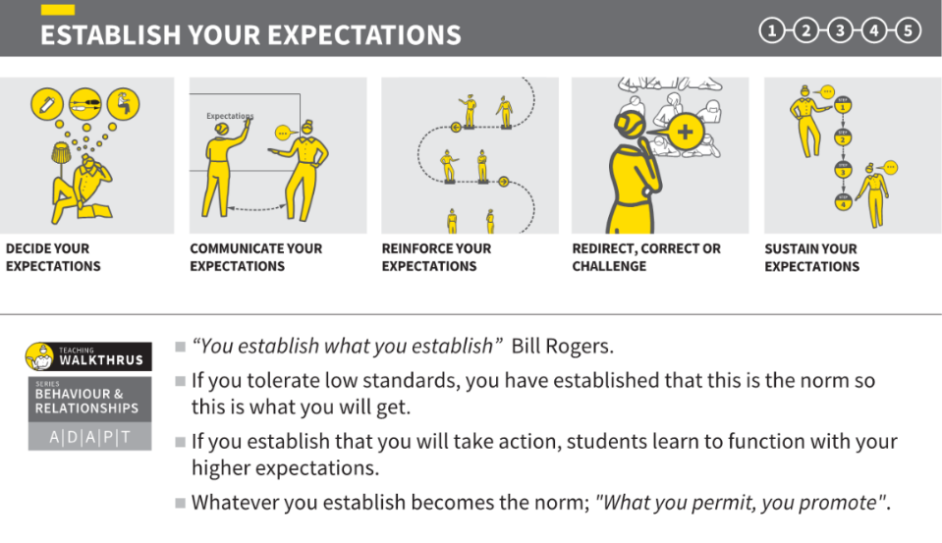

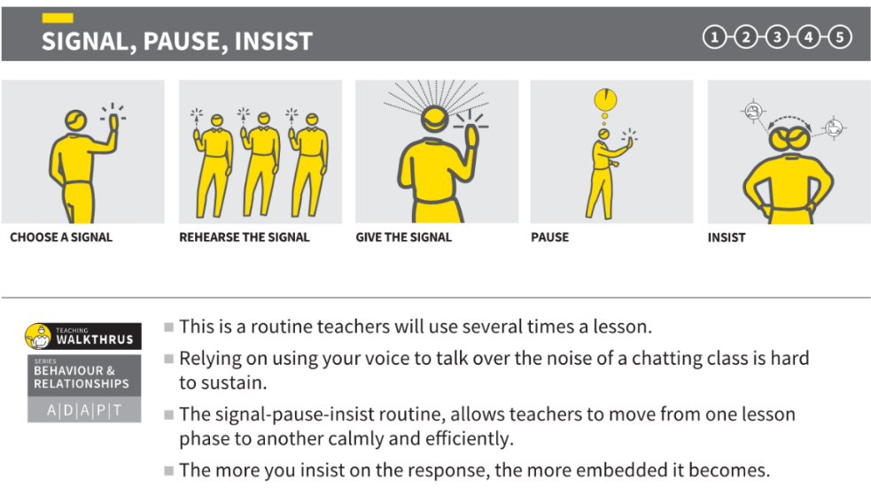

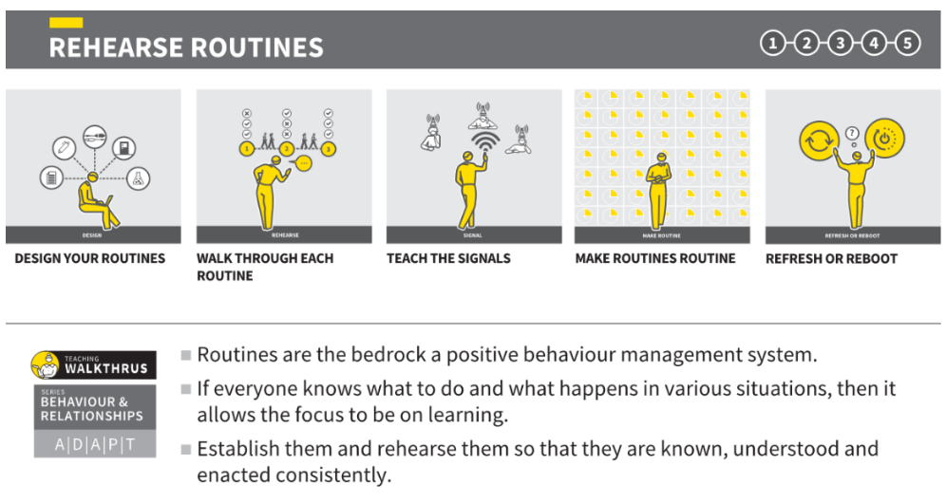

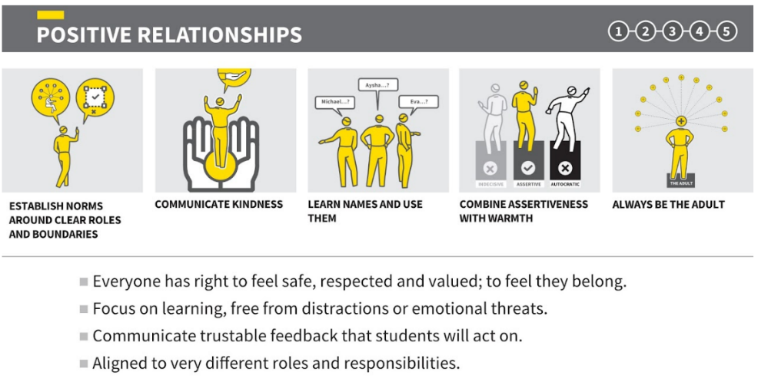

Zones of Regulation
These are used as a school-wide strategy to support children with developing an awareness of their emotional responses in life and strategies to support these. In order for a child to be ready for learning, they need to be able to self-regulate. For most children, they are able to regulate with ease. This tool supports children to better understand their own emotions and strategies that children can draw upon to support their own emotional regulation in each coloured area of the zones. When used effectively, children can better regulate and control their responses to overwhelming emotions, in turn maximising learning and emotional development and leaving children feeling empowered and in control of their emotions. The Zones of Regulation are particularly useful for children with SEND, such as SEMH needs and ASC.
Expectations:
- Children know how to access the visual resources of ZOR in their classroom
- All classrooms have visual resources on the walls and smaller more personalised resources can be created for any specific child in need of this
- All school adults wear the ZOR visual cards on lanyards to support ease of access for visual support for any child
- Children are aware of the language around zones, emotions and strategies to support
- Children can link these with the behaviour expectations but also know that all emotions are valid, whereas all behaviour is not acceptable

Restorative Practice
Woodlands Primary School uses Restorative Practice to promote good behaviour and resolve unacceptable behaviour in a fair and consistent way. The restorative questions are displayed in every classroom (Woodlands Behaviour Blueprint) and on the back of staff lanyards. Any form of humiliation or sarcasm is not acceptable. Every effort will be made to maintain safety and retain all children’s access to learning. Efforts will be made to establish the truth of a situation and a ‘cooling down’ period may be advisable. However, issues must be addressed appropriately and promptly. Decisions regarding consequences must be considered reasonable and not made on impulse. Where classroom behaviour is disruptive, teachers will apply the procedures from the behaviour policy steps.
At Woodlands we use reflective questions with visual support to walk through situations which require a consequence. This is carried out with a member of SLT in a lunchtime detention. They key message is always on ‘What impact has this had on myself and others? What can I do to put it right? What can I do differently next time?’ In this way, we work together with children and parents to ensure that children thrive. We also use ‘Reflection books’ with key visuals adapted for KS1 and KS2 to talk through situations where behaviour may not have met expectations. This supports children to reflect and move forwards with alternative strategies and skills.

PSHE
At Woodlands Primary School, we teach Personal, Social, Health Education as a whole-school approach to underpin children’s development as people and because we believe that this also supports their learning capacity. The Jigsaw Programme offers us a comprehensive, carefully- thought-through Scheme of Work which brings consistency and progression to our children’s learning in this vital curriculum area. The overview of the programme can be seen on the school website.
We also use circle times and targets session with classes and groups of children to support further exploration or development of a specific needs for exploring any element of the behaviour curriculum that needs specific input.
We have a wide range of books linked to emotions and behaviour that can be accessed for class, group or individual work. Such as ‘Ravi’s Roar,’ ‘My Big Bag of Worries,’ ‘The Colour Monster,’ ‘Listening to my Body.’

Impact

The impact of our behaviour curriculum is monitored and evaluated daily, termly and annually by the direct work of the Senior Leadership Team alongside the Governors. This includes observations, pupil voice, parent and staff surveys, visits by the Local Authority and peer reviews with other schools.
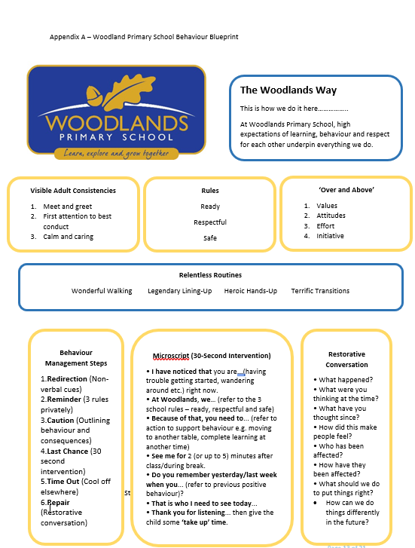

Appendix B – Overview of Behaviour Curriculum
All year groups from Reception to year 6 | Autumn term 1 | Autumn term 2 | Spring term 1 | Spring term 2 | Summer term 1 | Summer term 2
In-class explicit teaching | Explicit  teaching of the  full behaviour  curriculum  content – one full focus day at start of term | Revisit full content and any specific areas that need further support – sessions as needed within each class | Explicit  teaching of the  full behaviour  curriculum  content  Focus time on first day back after break | Revisit key areas that need development within individual classes - sessions as needed within each class | Explicit  teaching of the  full behaviour  curriculum  content  Focus time on first day back after break | Revisit key areas that need development within individual classes - sessions as needed within each class
Assembly | Values focus – Respect  -Being polite  -Being respectful  -All people are equally important  -Looking after others  -Treating others as we wish to be treated  -Looking after our environment | Values – Responsibility  -Being ready to learn and always trying our hardest  -Being honest  -Looking after our Earth  -The impact of our behaviour on others  -Anti-bullying week | Values- Resilience  -Developing our resilience  -Finding courage and perseverance  -Ability to deal with setbacks  -Working through ups and downs  -Mental health awareness week | Values – Compassion  -Showing compassion  -Awareness of the feelings of others -Bringing kindness into our everyday  -Celebrating differences  -Speaking out to keep me and others safe | Values – Creativity  -Exploring our strengths  -Being original  -Trying new experiences and skills  -Finding ways to express ourselves  -Thinking in different ways | Values – Community  -Making a positive difference  -How we impact others  -Being proud of our community  -Brining happiness to others  -Working together to achieve greater things
 | The start and end of each term is a behaviour focus assembly to re-establish expectations and review behaviour with an explicit focus for an improvement area.
PSHE | BM (Being Me in My World)  'Who am I and how do I fit?'  Key themes explored:  -understanding our individual strengths and differences -exploring gratitude -opportunities and goals and how to achieve them | CD (Celebrating Difference)  Respect for similarity and difference. Anti-bullying and being unique  Key themes explored:  -developing awareness of cultures  -discrimination  -racism  -bullying | DG (Dreams and Goals)  Aspirations, how to achieve goals and understanding the emotions that go with this  Key themes explored:  -perseverance  -opportunities -achievements  -problem solving  -team work | HM (Healthy Me)  Being and keeping safe and healthy  Key themes explored:  -healthy and unhealthy behaviours -looking after our mental and physical health -supporting emotional regulation | RL (Relationships)  Building positive, healthy relationships  Key themes explored:  -friendships -relationships -self-esteem -confidence -family roles and -responsibility -safety online | CM (Changing Me)  Coping positively with change  Key themes explored:  -understand that everyone is unique and special -expressing oneself -when change happens knowing how to ask for help -understanding of emotional and physical changes in growing up

