Special Educational Needs and Disabilities (SEND) Information Report
Woodlands Primary School



Inclusion Team
SEND Governor:
Caroline Pearce
Assistant Headteacher/Inclusions Manager/SENCO & DSL
Lucy Husband
Contact No. 01732 355577
lhusband@woodlands.kent.sch.uk

Approved by: | Governors | Date: July 2026
Last reviewed on: | July 2026
Next review due by: | July 2027

Contents
1. What types of SEND does the school provide for? 4
2. Which staff will support my child? 5
3. What should I do if I think my child has SEND? 7
4. What happens if the school identifies a need? 8
5. How will the school measure my child’s progress? 9
6. How will I be involved in decisions made about my child’s education? 10
7. How will my child be involved in decisions made about their education? 11
8. How will the school adapt its teaching for my child? 12
9. How will the school evaluate whether the support in place is helping my child? 13
10. How will the school ensure my child has appropriate resources? 13
11. How will the school make sure my child is included in activities alongside pupils who don’t have SEND? 14
12. How does the school make sure the admissions process is fair for pupils with SEN or a disability? 15
13. How does the school support pupils with disabilities? 15
14. How will the school support my child’s mental health and emotional and social development? 16
15. What support is in place for looked-after and previously looked-after children with SEN? 16
16. What support will be available for my child as they transition between classes or settings or in preparing for adulthood? 17
17. What support is available for me and my family? (Local Offer) 18
18. What should I do if I have a complaint about my child’s SEND support? 19
19. Supporting Documents…………………………………………………………………………………………………………….19
20. Glossary 20

Dear parents and carers,
The aim of this Information Report is to explain how we implement our SEND policy. In other words, we want to show you how SEND support works in our school.
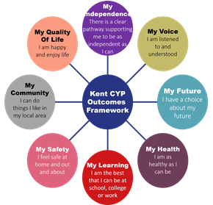
As educational professionals, we are all working towards the ultimate goal of growing independent young people as they prepare for adulthood. All provision and support we provide is working towards achieving the Kent Children and Young People (CYP) Outcomes Framework:

If you want to know more about our arrangements for SEND, read our SEND policy alongside this Information Report.
You can find our SEND policy on our website Woodlands Primary School - Policies
Note: If there are any terms we’ve used in this information report that you’re unsure of, you can look them up in the Glossary at the end of the report.

1. What types of SEND does the school provide for?

Our school provides for pupils with the following needs (as outlined in the SEND Code of Practice 2015):

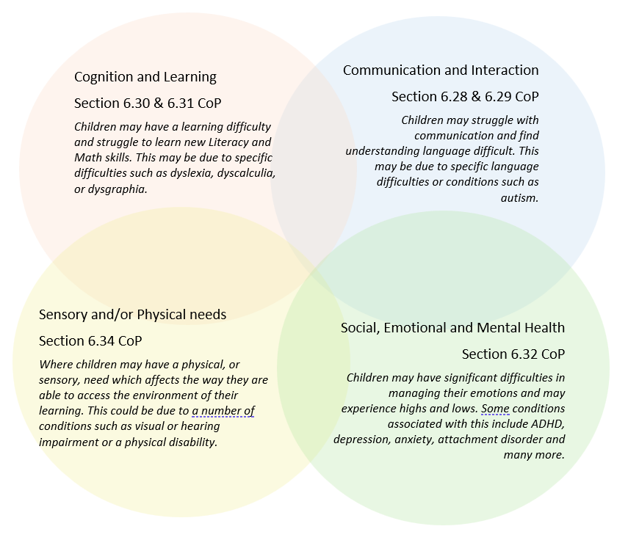

Often you will find that children’s needs overlap and are rarely confined to one area of need, which is why it is important to gain a holistic overview of your child.
More information about the Areas of Need can be found in the Special educational needs and disability code of practice: 0 to 25 years (link below).
SEND_Code_of_Practice_January_2015.pdf (publishing.service.gov.uk)

2. Which staff will support my child, and what are their key responsibilities?

At Woodlands Primary School, every member of staff has a responsibility for ensuring that pupils with Special Educational Needs and Disabilities (SEND) receive high-quality, inclusive teaching and are supported to achieve their full potential.
We believe that the most effective support for children with SEND comes from excellent classroom teaching, carefully planned adaptations and strong partnerships between school, parents and external professionals. All staff receive regular professional development to ensure they have the knowledge, skills and confidence to meet a wide range of additional needs.
Our Inclusion Team works closely with class teachers, teaching assistants, parents and outside agencies to ensure that support is tailored to each child's individual strengths and needs.
Our Special Educational Needs Co-ordinator, or SENCO
Lucy Husband is Woodlands Primary School's Assistant Headteacher, Inclusions Manager, Special Educational Needs Coordinator (SENCO) and Designated Safeguarding Lead (DSL).
Lucy is a qualified teacher and experienced SENCO who has extensive experience supporting pupils with a wide range of special educational needs, including Autism Spectrum Condition (ASC), ADHD, speech, language and communication needs, social, emotional and mental health needs, sensory differences and specific learning difficulties.
As SENCO, Lucy is responsible for:
- Coordinating provision for pupils with SEND across the school.
- Supporting teachers to identify and meet pupils' needs through the Graduated Approach.
- Working alongside families to ensure they are fully involved in decisions regarding their child's education.
- Monitoring the progress of pupils receiving SEND Support.
- Coordinating Education, Health and Care Needs Assessments (EHCNAs), Annual Reviews and SEND Support Plans.
- Liaising with external professionals including Educational Psychologists, Speech and Language Therapists, Occupational Therapists, Specialist Teachers and Health Services.
- Ensuring that Woodlands continues to develop an inclusive culture where every child feels valued and able to succeed.
- Providing training and guidance for staff to continually develop inclusive classroom practice.
The SENCO can be contacted via the school office on 01732 355577 or by email at lhusband@woodlands.kent.sch.uk.
Mrs. Adams is the Assistant Headteacher and part of the Inclusion Team, with responsibility for Wellbeing, Attendance and Pupil Premium aadams@woodlands.kent.sch.uk.
Miss Emily Bowen is the Assistant to the Inclusion Team. ebowen@woodlands.kent.sch.uk
Mrs. Jo Stone is the Pastoral Support Office and part of the Inclusion Team. jstone@woodlands.kent.sch.uk
The school's SEND Governor is Caroline Pearce.
The SEND Governor meets regularly with the SENCO to monitor the effectiveness of SEND provision, ensure statutory responsibilities are met and provide appropriate challenge and support to school leaders. They report to the Governing Body regarding the effectiveness of the school's inclusive practice.
The SENCO has an important role to play with the headteacher and governing body with regards to the strategic oversight and implementation of Woodlands Primary School‘s SEN policy and development.

Class/subject teachers
The class teacher has the primary responsibility for the progress and development of every child in their class, including those with SEND.
Teachers plan and deliver high-quality, inclusive teaching which is carefully adapted to meet individual needs. This includes implementing reasonable adjustments, monitoring progress, reviewing the effectiveness of support and working closely with parents and the Inclusion Team.
Teachers work within Kent's Mainstream Core Standards and are supported by the SENCO to ensure pupils can access a broad, balanced and ambitious curriculum.
Teaching assistants (TAs)
We have a team of 17 fantastic teaching assistants.
Teaching assistants play an important role in supporting inclusion throughout the school.
At Woodlands, teaching assistants are deployed strategically to maximise learning and promote independence. We do not operate a blanket one-to-one teaching assistant model, as research demonstrates that pupils make the greatest progress when high-quality teaching remains at the centre of their learning.
Teaching assistants may:
- Deliver evidence-based intervention programmes.
- Support small group learning.
- Reinforce and pre-teach learning introduced by the class teacher.
- Implement recommendations from external professionals.
- Provide scaffolding to enable pupils to become increasingly independent learners.
- Support pupils to develop communication, social interaction and emotional regulation.
- Assist with reasonable adjustments to ensure pupils can fully access classroom learning.
Where pupils require more intensive adult support, this is planned carefully according to identified need and is reviewed regularly to ensure that independence remains the long-term goal.
External agencies
Sometimes we need extra help to offer our pupils the support that they need. Whenever necessary we will work with external support services to meet the needs of our pupils with SEND and to support their families. These may include:

- Child and adolescent mental health services (CAMHS)
- Education welfare officers
- Educational psychologists
- GPs or paediatricians
- NELFT practitioners
- Occupational therapists
- Therapeutic practitioners
- Behaviour coaches
- Safeguarding services
- School nurses
- SEND Inclusion Advisor
- Specialist Teacher Service
- Speech and language therapists



- Voluntary sector organisations

3. What should I do if I think my child has SEND?

At Woodlands Primary School, we value the knowledge and expertise that parents and carers have about their children. If you have any concerns about your child's learning, development, behaviour or wellbeing, we encourage you to speak to us as early as possible. Early identification enables us to work together to remove barriers to learning and provide support at the earliest opportunity.

Phase 1 – Share your concerns
If you think your child may have a special educational need or disability, your first point of contact should be your child's class teacher. They know your child well and are best placed to discuss your concerns and explain the support already in place.
You can speak to your child's teacher informally at the end of the school day, arrange a meeting through the school office or contact them via the school communication system. If appropriate, the class teacher will also involve the SENCO, Miss Lucy Husband, to provide additional advice and guidance.

Phase 2 – Working together
We will arrange a meeting with you to gain a full understanding of your child's strengths, interests and areas of difficulty. We believe that parents are key partners in this process and your views are invaluable in helping us build a complete picture of your child's needs.
During this stage we may:
- discuss your child's progress, attainment and wellbeing;
- consider any previous assessments or reports;
- gather the views of your child, where appropriate;
- review classroom observations and assessment information;
- agree any immediate strategies or reasonable adjustments that may support your child.
A record of the discussion and agreed actions will be kept and shared with relevant staff.

Phase 3 – Implementing support
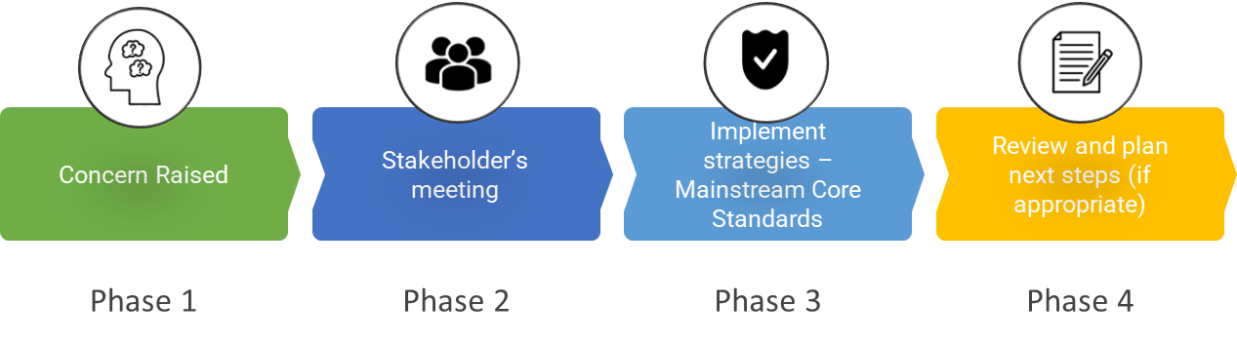
In most cases, the first response will be to strengthen the support already available through high-quality teaching and the Kent Mainstream Core Standards. Your child's class teacher will implement appropriate classroom adaptations and, where necessary, targeted interventions to address identified areas of need.
Examples of support may include:
- adapted teaching approaches;
- scaffolded learning activities;
- visual supports and timetables;
- pre-teaching of vocabulary and concepts;
- targeted intervention programmes;
- adapted resources or recording methods;
- sensory or movement breaks;
- small-group support.
This forms part of the Graduated Approach (Assess, Plan, Do, Review), where support is carefully monitored and adjusted according to your child's progress.

Phase 4 – Reviewing progress
After an agreed period, we will review the impact of the support that has been provided. This review will involve parents, the class teacher and, where appropriate, the SENCO and your child.
Many children make good progress following targeted classroom adaptations and no further intervention is required beyond high-quality inclusive teaching.
Where evidence shows that a child requires provision that is additional to or different from that which is ordinarily available through Quality First Teaching and the Kent Mainstream Core Standards, they may be identified as requiring SEND Support and be added to the school's SEND Register.
At this point, an individual personalised learning plan will be developed in partnership with parents, appropriate outcomes will be agreed, and the Assess, Plan, Do, Review cycle will continue to ensure support remains effective and responsive to your child's changing needs.
Where necessary, we may also seek advice from external professionals, such as Educational Psychologists, Speech and Language Therapists or Occupational Therapists, to help us better understand your child's needs and plan appropriate provision.

4. What happens if the school identifies a need?
At Woodlands Primary School, identifying and responding to pupils' needs is a shared responsibility. Concerns may be raised by parents or carers, class teachers, teaching assistants, external professionals or through our ongoing assessment and monitoring processes.
We recognise that every child develops at their own pace and that some pupils may require additional support to overcome barriers to learning. Early identification enables us to put appropriate support in place as quickly as possible and helps to ensure pupils achieve the best possible outcomes.
Children are identified through a range of information, which may include:
- day-to-day teacher observations;
- ongoing assessment of progress and attainment;
- pupil progress meetings;
- concerns regarding communication, learning, behaviour or emotional wellbeing;
- attendance and engagement with learning;
- discussions with parents and carers;
- pupil voice;
- information from previous educational settings;
- reports from health or other external professionals;
- universal screening and assessment tools where appropriate.
At Woodlands, we regularly use a range of screening and assessment tools to help us develop a better understanding of a child's strengths and areas of need. These may include Speech Link, Language Link, Boxall Profile, dyslexia screening, sensory checklists and other assessment tools, alongside advice from specialist services where appropriate.
When a concern is identified, the class teacher will first review the support already in place and ensure that high-quality teaching has been appropriately adapted in line with the Kent Mainstream Core Standards. The teacher will work closely with the SENCO to consider what further adjustments or targeted interventions may be appropriate.
In many cases, children make good progress following carefully planned classroom adaptations and targeted intervention. These pupils do not necessarily have Special Educational Needs and may simply require short-term support to address gaps in learning or development.
Where a child continues to experience significant difficulties despite high-quality teaching and appropriate targeted support, we will meet with parents to discuss whether the child may require SEND Support. Decisions are always based on a range of evidence rather than a single assessment or observation.
If a child is identified as requiring provision that is additional to or different from the provision that is ordinarily available within the classroom, they may be placed on the school's SEND Register. This decision will always be discussed and agreed in partnership with parents.
Once a pupil is receiving SEND Support, we follow a graduated approach using the Assess, Plan, Do, Review cycle (see section 5) to ensure provision remains appropriate, effective and responsive to changing needs. Targets are reviewed regularly and support is adapted in response to the child's progress.
Where appropriate, and with parental consent, we may seek advice from external professionals such as Educational Psychologists, Speech and Language Therapists, Occupational Therapists, the Specialist Teaching and Learning Service (STLS), SEND Inclusion Advisers, Community Paediatricians or other health professionals to gain a more detailed understanding of a child's needs and to inform future planning.
At every stage of the process, we work closely with parents and carers, recognising that they know their child best. By combining the expertise of families, school staff and external professionals, we aim to build a complete picture of each child's strengths and needs and provide the right support at the right time.
5. How will the school measure my child’s progress?
At Woodlands Primary School, we carefully monitor the progress and wellbeing of every pupil to ensure that they are making the best possible progress from their individual starting points. We recognise that progress is not measured solely by academic attainment and that success can also be seen in areas such as communication, independence, confidence, emotional wellbeing, social development and readiness to learn.
The class teacher has overall responsibility for monitoring the progress of every child in their class, including pupils with SEND. They work closely with the SENCO and other members of the Inclusion Team to review the effectiveness of support and make any necessary adjustments.

The Graduated Approach
For pupils receiving SEND Support, we use the Assess, Plan, Do, Review cycle to ensure provision remains effective and responsive to individual needs.

Assess
We gather information from a range of sources to build a comprehensive understanding of your child's strengths and areas of need. This may include:
- teacher assessments and observations;
- pupil progress data;
- intervention assessments;
- discussions with parents and carers;
- pupil voice;
- advice from external professionals where appropriate.

Plan
Using this information, we work collaboratively with parents, pupils and staff to agree meaningful outcomes and identify the most appropriate support. This may include classroom adaptations, targeted interventions or specialist recommendations.

Do
The agreed provision is delivered by the class teacher, supported where appropriate by teaching assistants or specialist staff. The class teacher remains responsible for your child's progress, ensuring that support is implemented consistently and that learning is carefully adapted to meet individual needs.

Review
Support is reviewed regularly to evaluate its impact. We consider the progress your child has made towards their agreed outcomes, alongside their wider development, engagement and wellbeing. Following each review, support may continue, be adapted, be reduced or, where appropriate, be discontinued if it is no longer required.

How we monitor progress
We evaluate progress using a range of information rather than relying on a single assessment. This may include:
- ongoing classroom assessment;
- termly pupil progress meetings;
- attainment and progress data;
- observations of learning and engagement;
- intervention entry and exit assessments;
- attendance and wellbeing information;
- feedback from parents and carers;
- pupil voice;
- reports and recommendations from external professionals.
For pupils receiving SEND Support, outcomes and provision are formally recorded in the pupil’s personalised learning plan which is reviewed at least three times each academic year, with parents invited to discuss progress and agree next steps. Pupils with an Education, Health and Care Plan (EHCP) also receive an Annual Review in accordance with statutory guidance.

Evaluating the effectiveness of provision
The SENCO regularly monitors the quality and impact of SEND provision across the school through:
- review meetings with class teachers;
- monitoring of provision maps and intervention records;
- analysis of pupil progress and attainment;
- learning walks and classroom observations;
- scrutiny of pupils' work;
- discussions with pupils and parents;
- evaluation of intervention programmes.
This enables us to ensure that support is evidence-informed, targeted effectively and represents good value in improving outcomes for children.
Where a pupil is making expected progress, support may be gradually reduced as they become increasingly independent. If progress is slower than expected, we will work with parents to review the provision in place and consider whether further assessment, additional intervention or advice from external professionals is required.
At Woodlands, our aim is always to provide the right support, at the right time, enabling every child to become a confident, resilient and independent learner who is able to thrive both academically and personally.

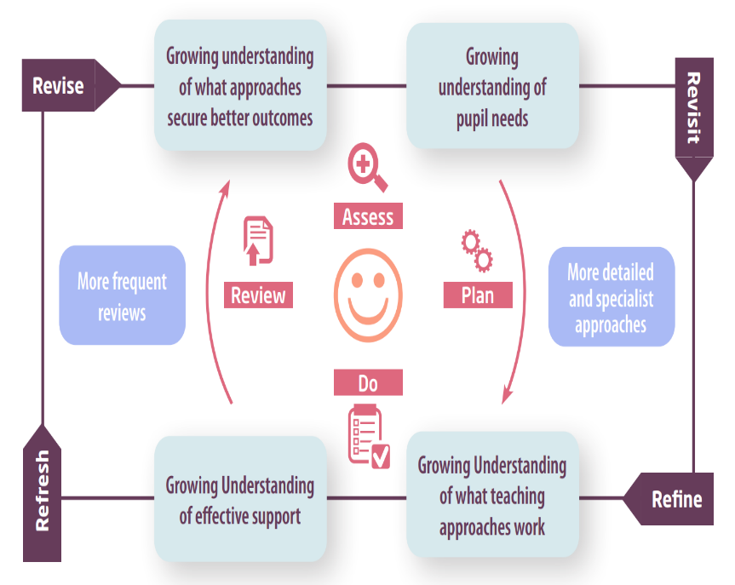

6. How will I be involved in decisions made about my child’s education?
At Woodlands Primary School, we believe that parents and carers know their children best and are essential partners in supporting their learning, development and wellbeing. We value open, honest communication and work closely with families to ensure that decisions about a child's education are made collaboratively.
All parents are invited to attend two Parents' Evenings each academic year, providing an opportunity to discuss their child's progress, attainment, wellbeing and next steps with the class teacher. In addition, parents receive a written end-of-year report, summarising their child's achievements, progress and areas for future development.
For pupils receiving SEND Support, parents are involved more frequently through the review of their child's Personal Learning Plan (PLP). PLPs identify a child's individual strengths, agreed outcomes and the provision being put in place to support them.
PLPs are reviewed six times each academic year to ensure that support remains appropriate and responsive to a child's changing needs. These reviews provide opportunities to:
- celebrate progress and achievements;
- review progress towards agreed outcomes;
- discuss the effectiveness of the provision in place;
- agree any changes to support or teaching strategies;
- set new outcomes where appropriate; and
- ensure that parents' views continue to inform future planning.
Where a child has an Education, Health and Care Plan (EHCP), parents are also invited to attend the child's Annual Review, where progress towards the outcomes within the EHCP is evaluated and future provision is planned in partnership with school staff and external professionals.
Communication with families is not limited to formal meetings. Parents are encouraged to contact their child's class teacher whenever they have concerns or wish to discuss their child's progress. Where appropriate, the SENCO may also attend meetings or arrange additional appointments to provide further advice and support.
We recognise that children develop at different rates and that their needs may change over time. By maintaining strong partnerships between home and school, we can work together to ensure that every child receives the support they need to achieve their full potential and become confident, independent learners.

7. How will my child be involved in decisions made about their education?
The level of involvement will depend on your child’s age and individual needs. We recognise that no two pupils are the same, so we will decide on a case-by-case basis, with your input.
We may seek your child’s views by asking them to:
- Attend meetings to discuss their progress and outcomes
- Prepare a presentation, written statement, video, drawing, etc.
- Discuss their views with a member of staff who can act as a representative during the meeting
- Complete a survey

8. How will the school adapt its teaching for my child?
At Woodlands Primary School, we are committed to providing an inclusive learning environment where every child can access a broad, balanced and ambitious curriculum. We believe that the foundation of effective SEND provision is high-quality, inclusive teaching, with adaptations made to meet the needs of individual learners.
Our approach is guided by the SEND Code of Practice (2015) and the Kent Mainstream Core Standards, which set out the provision that all mainstream schools should make available for children and young people with SEND.
The class teacher has overall responsibility for the progress and development of every child in their class. They work closely with the SENCO and Inclusion Team to identify barriers to learning and make appropriate adaptations so that pupils can participate successfully in all aspects of school life.
There is no 'one size fits all' approach to supporting pupils with SEND. Adaptations are planned according to each child's individual strengths, needs and learning profile, and are reviewed regularly to ensure they remain effective.

Quality First Teaching
High-quality teaching is the first and most important step in meeting the needs of pupils with SEND. Teachers carefully adapt their teaching to enable all pupils to access learning successfully alongside their peers.
Adaptations may include:
- carefully scaffolded learning tasks;
- breaking learning into smaller, manageable steps;
- pre-teaching key vocabulary and concepts;
- visual timetables, symbols and prompts;
- adapting questioning to support understanding;
- providing additional processing time;
- modelling and demonstrating new learning;
- flexible grouping arrangements;
- adapted resources and recording methods;
- the use of assistive technology where appropriate;
- sensory or movement breaks;
- predictable routines and well-structured learning environments;
- adapted feedback to support next steps in learning.
These adaptations enable pupils to become increasingly independent and confident learners while remaining fully included within the classroom.

Targeted Support
Where additional support is required, pupils may access short-term or longer-term targeted interventions alongside high-quality classroom teaching. These interventions are carefully selected to address identified areas of need and are monitored regularly to ensure they are making a positive impact.
Depending on a child's individual needs, support may include interventions relating to:
Communication and Interaction
- Speech and Language programmes
- Language Link
- Speech Link
- Colourful Semantics
- Social communication groups
- Lego Therapy
- Vocabulary pre-teaching
Cognition and Learning
- Daily Readers
- Guided Reading
- Read Write Inc. interventions
- Lexia
- Reading comprehension support
- Small-group English and Maths support
- Handwriting and spelling interventions
Social, Emotional and Mental Health
- Breakfast Nurture
- Nurture Lunch groups
- Daily check-ins
- Mentoring
- Drawing and Talking Therapy
- Lego Therapy
- TLG mentoring
- NELFT programmes
Sensory and Physical Needs
- Sensory Circuits
- Fine motor programmes
- Handwriting support
- Adapted classroom environments
- Specialist equipment where recommended by external professionals
Interventions are reviewed regularly to ensure they are effective and that pupils continue to make progress towards their individual outcomes.

The Role of Teaching Assistants
Teaching Assistants are an important part of our inclusive provision and work closely with teachers to support learning throughout the school.
At Woodlands, teaching assistants are deployed strategically according to identified need. Research shows that pupils make the greatest progress when they receive high-quality teaching from their class teacher, supported by carefully planned adult assistance where appropriate.
Teaching Assistants may:
- deliver evidence-based intervention programmes;
- facilitate small-group learning;
- reinforce and pre-teach learning introduced by the class teacher;
- support recommendations from external professionals;
- provide carefully planned scaffolding to promote independence;
- support pupils' communication, social interaction and emotional regulation;
- help pupils access learning alongside their peers.
While some pupils may require additional adult support at certain times, our aim is always to develop confidence, resilience and independence so that children become increasingly able to manage their own learning.

Working with External Professionals
Where appropriate, we work collaboratively with a range of external professionals, including Educational Psychologists, Speech and Language Therapists, Occupational Therapists, the Specialist Teaching and Learning Service (STLS), SEND Inclusion Advisers and health professionals.
Advice from these specialists is incorporated into classroom practice and individual support plans to ensure pupils receive the most appropriate provision.
At Woodlands, we believe that by combining high-quality teaching, carefully planned adaptations, targeted intervention and strong partnerships with families, every child can flourish and achieve their full potential within an inclusive school community.

9. How will the school evaluate whether the support in place is helping my child?

At Woodlands Primary School, we are committed to ensuring that the support we provide has a positive impact on pupils' learning, wellbeing and independence. We regularly review the effectiveness of our SEND provision to ensure that each child receives the right support at the right time.
The class teacher, supported by the SENCO, is responsible for monitoring the impact of any additional provision. Support is reviewed regularly and adapted where necessary to ensure it continues to meet a child's changing needs.
We evaluate the effectiveness of SEND provision through a range of measures, including:
- regular reviews of pupils' Personal Learning Plans (PLPs);
- ongoing teacher assessment and classroom observations;
- monitoring pupils' progress towards their individual outcomes;
- analysis of attainment and progress data;
- entry and exit assessments for intervention programmes;
- discussions with pupils about their learning and wellbeing (pupil voice);
- feedback from parents and carers;
- advice and recommendations from external professionals, where involved.
For pupils receiving SEND Support, Personal Learning Plans are reviewed six times each academic year. These reviews provide an opportunity to celebrate progress, evaluate the impact of current provision and agree any changes needed to support continued progress.
Where a pupil has an Education, Health and Care Plan (EHCP), an Annual Review is held in line with statutory guidance. This meeting brings together parents, school staff and any relevant professionals to review progress towards the outcomes in the EHCP and consider whether any amendments to provision are required.
The SENCO also evaluates the effectiveness of SEND provision across the school through:
- monitoring the quality of teaching and adaptive practice;
- reviewing intervention programmes and provision maps;
- learning walks and classroom visits;
- discussions with teachers, teaching assistants and pupils;
- analysing whole-school SEND progress and attainment data;
- evaluating the impact of staff training and professional development.
If a child is making good progress, support may be reduced or adapted to encourage increasing independence. If progress is slower than expected, we will work in partnership with parents to review the support in place, consider further assessment and, where appropriate, seek advice from external professionals to ensure that provision continues to meet the child's needs.
At Woodlands, SEND provision is never static. We continually review and refine our practice to ensure that every child receives effective, evidence-informed support that enables them to achieve their full potential.
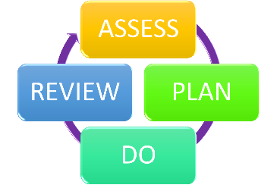

10. How will the school ensure my child has appropriate resources?
At Woodlands Primary School, we are committed to ensuring that every pupil with SEND has access to the support, resources and provision they need to achieve their full potential. We use our best endeavours, as required by the Children and Families Act (2014), to meet the needs of all pupils with SEND through high-quality teaching, reasonable adjustments and carefully targeted provision.

How SEND is funded
All mainstream schools receive funding to support pupils with Special Educational Needs and Disabilities through their delegated school budget. Within this is an identified notional SEN budget, which is intended to help schools meet the additional needs of pupils with SEND. The notional SEN budget is not additional or ring-fenced funding, but forms part of the school's overall budget. Schools are expected to use these resources to provide the first £6,000 of additional support required by a pupil with SEND, where appropriate. (GOV.UK)
This funding enables us to provide a wide range of inclusive support, including:
- high-quality adaptive teaching;
- evidence-based intervention programmes;
- specialist resources and equipment;
- staff training and professional development;
- targeted teaching assistant support;
- reasonable adjustments to enable pupils to access learning;
- advice and support from external professionals.
The level and type of support provided is determined by a child's individual needs rather than by a diagnosis or level of funding.

Education, Health and Care Plans (EHCPs)
Where a pupil has an Education, Health and Care Plan (EHCP), Kent County Council may provide High Needs Top-Up Funding where it has been agreed that the child's needs cannot reasonably be met through the school's delegated resources alone.
This funding contributes towards the additional provision specified within the EHCP but does not fund a named member of staff or guarantee one-to-one support. Instead, funding enables the school to provide the specialist provision, staffing, resources and adjustments required to meet the outcomes described within the child's Education, Health and Care Plan. Provision is planned flexibly to ensure pupils receive the support they need while promoting independence and inclusion.

Kent's SEND Funding Arrangements
Kent County Council has introduced a revised funding model for mainstream schools as part of its wider Communities of Schools approach to inclusion. The aim of this model is to ensure that funding is allocated more fairly, enabling schools to respond to pupils' needs at the earliest opportunity and reduce reliance on statutory assessment where appropriate. (kelsi.org.uk)
This funding model recognises that children with SEND may require varying levels of support throughout their education and encourages schools to work collaboratively to ensure resources are used effectively to improve outcomes for all pupils.

Making Best Use of Resources
At Woodlands, decisions about the deployment of staff and resources are always based on a careful assessment of individual need. We regularly review the impact of the support we provide to ensure that resources are being used effectively and continue to represent the best possible provision for each child.
Where appropriate, we work closely with external professionals, including Educational Psychologists, Speech and Language Therapists, Occupational Therapists, the Specialist Teaching and Learning Service (STLS) and SEND Inclusion Advisers. Their recommendations help us identify any specialist equipment, resources or environmental adaptations that may be required.
Additional resources may include:
- assistive technology;
- adapted classroom equipment;
- sensory resources;
- specialist seating or writing equipment;
- communication aids;
- visual supports;
- bespoke intervention programmes;
- environmental adaptations to improve access to learning.
Our aim is to ensure that every child receives the support they need to access the curriculum successfully, participate fully in school life and develop the confidence and independence needed to thrive both now and in the future.

11. How will the school make sure my child is included in activities alongside pupils who don’t have SEND?


The expectation is that all schools providing an inclusive provision for all pupils. It may be necessary for some pupils to receive interventions in addition to a broad and balanced curriculum.
All of our extra-curricular activities and school visits are available to all our pupils, including our before and after-school clubs.
All pupils are encouraged to go on our school trips, including our residential trips to Carroty Wood in Year 5 and Devon in Year 6.
All pupils are encouraged to take part in sports day/school plays/special workshops.
No pupil is ever excluded from taking part in these activities because of their SEN or disability and we will make whatever reasonable adjustments are needed to make sure that they can be included.

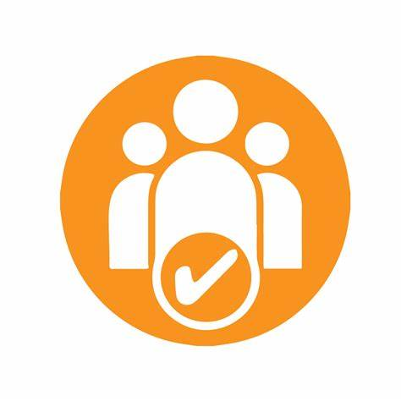
12. How does the school make sure the admissions process is fair for pupils with SEN or a disability?

See Accessibility Plan for more information Woodlands Primary School - Policies
You’re disabled under the Equality Act 2010 if you have a physical or mental impairment that has a ‘substantial’ and ‘long-term’ negative effect on your ability to do normal daily activities.

14. How will the school support my child’s mental health and emotional and social development?
At Woodlands Primary School, we recognise that positive mental health and emotional wellbeing are fundamental to a child's ability to learn, build positive relationships and achieve their full potential. We are committed to creating a safe, nurturing and inclusive environment where every child feels valued, respected and able to thrive.
We believe that all children should be fully included in every aspect of school life. Pupils with SEND are encouraged and supported to participate in the same opportunities as their peers, including school trips, educational visits, enrichment activities, extra-curricular clubs, performances, leadership opportunities and the School Council. Where necessary, reasonable adjustments are made to ensure that all children can access these experiences and feel a valued part of our school community.
Promoting emotional wellbeing is everyone's responsibility. Our whole-school approach is built upon positive relationships, consistent routines, high expectations and an inclusive ethos that helps children feel safe, confident and ready to learn. Class teachers and support staff know their pupils well and work closely with families to identify any concerns at the earliest opportunity.
Where a child requires additional support with their emotional wellbeing, we offer a graduated range of interventions tailored to individual need. These may include:
- Breakfast Nurture (by invitation only) providing a calm and supportive start to the school day for pupils who benefit from additional emotional support and opportunities to develop positive relationships.
- Nurture Lunch Groups, offering structured opportunities for children to build friendships, develop social skills and increase their confidence in a supportive environment.
- Check ins, providing regular opportunities for pupils to meet with a trusted adult to discuss worries, celebrate successes and develop strategies to manage challenges.
- Drawing and Talking Therapy, delivered by trained members of staff, enabling children to explore and process emotions through a structured therapeutic approach that promotes emotional resilience and wellbeing.
- Referral to the School Health Emotional Wellbeing Team (School Nursing Service), who provide advice, consultation and targeted support for children experiencing emerging emotional wellbeing or mental health needs.
- Referral to the NELFT Emotional Wellbeing Team, who work with schools and families to provide evidence-based support for children experiencing anxiety, low mood, emotional regulation difficulties and other mental health concerns.
- One-to-one counselling with an independent qualified counsellor, Ali Crawford, where this is considered appropriate and funding is available. Counselling may be accessed through external funding or other agreed arrangements following discussion with parents and the school.
Where appropriate, we also work closely with a range of external professionals, including health services, Early Help, Children's Social Care and Child and Adolescent Mental Health Services (CAMHS), to ensure that children and families receive coordinated support when more specialist intervention is required.
Listening to the voices of our pupils is central to our inclusive approach. We encourage children to share their thoughts, feelings and aspirations and ensure that their views are considered when planning support. Staff regularly check in with pupils who may need additional encouragement or reassurance, helping them to develop confidence, resilience and positive relationships.

Preventing Bullying
Woodlands Primary School has a zero-tolerance approach to bullying. We promote kindness, empathy, respect and inclusion through our curriculum, assemblies, PSHE lessons and everyday interactions.
We recognise that some children with SEND may be more vulnerable to bullying or social isolation. Staff remain vigilant, respond promptly to any concerns and work closely with pupils and families to ensure that all children feel safe, accepted and included within our school community.
By fostering a culture where every child feels that they belong, alongside providing graduated pastoral and therapeutic support when needed, we aim to develop emotionally resilient, confident learners who are able to flourish both in school and beyond.

15. What support is in place for looked-after and previously looked-after children with SEND?


Lucy Husband is the Designated Teacher for Looked After Children (DT/DLAC) at Woodlands. She will make sure that all teachers understand how a looked-after or previously looked-after pupil’s circumstances and their SEND might interact, and what the implications are for teaching and learning.
Pupils who are looked-after or previously looked-after will be supported much in the same way as any other child who has SEND. However, looked-after pupils will also have a personal education plan (PEP). We will make sure that the PEP and any SEND support plans or EHC plans are consistent and complement one another.

16. What support will be available for my child as they transition between classes or settings or in preparing for adulthood?
Between years
To help pupils with SEND be prepared for a new school year we:
Ask both the current teacher and the next year’s teacher to attend final meeting of the year when the pupil’s SEND is discussed

Schedule lessons with the incoming teacher towards the end of the summer term
Between schools
When your child is moving on from our school, we will ask you and your child what information you want us to share with the new setting.
Moving onto secondary school
The SENCO of the secondary school will come into our school for a meeting with our SENCO. They will discuss the needs of all the pupils who are receiving SEND support.

Pupils will be prepared for the transition by:
- Practising with a secondary school timetable
- Learning how to get organised independently
- Plugging any gaps in knowledge

17. What support is available for me and my family?
If you have questions about SEND, or are struggling to cope, please get in touch to let us know. We want to support you, your child and your family.
To see what support is available to you locally, have a look at Kent’s Local Offer:
About the SEND local offer - Kent County Council
Our local special educational needs and disabilities information advice and support services (SENDIASS) organisations are:
SENDIASS
Home | IASK

National charities that offer information and support to families of pupils with SEND are:
- IPSEA
- SEND family support
- NSPCC
- Family Action
- Special Needs Jungle

18. What should I do if I have a complaint about my child’s SEND support?
Please see here for the school’s complaint policy: Complaints Policy 2022
Complaints about SEND provision in our school should be made to the heafdteacher, Mrs. Vicki Lonie, in the first instance. They will then be referred to the school’s complaints policy.
If you are not satisfied with the school’s response, you can escalate the complaint. In some circumstances, this right also applies to the pupil themselves.
To see a full explanation of suitable avenues for complaint, see pages 246 and 247 of the SEND Code of Practice.
If you feel that our school discriminated against your child because of their SEND, you have the right to make a discrimination claim to the first-tier SEND tribunal. To find out how to make such a claim, you should visit: https://www.gov.uk/complain-about-school/disability-discrimination
You can make a claim about alleged discrimination regarding:
- Admission
- Exclusion
- Provision of education and associated services
- Making reasonable adjustments, including the provision of auxiliary aids and services
Before going to a SEND tribunal, you can go through processes called disagreement resolution or mediation, where you try to resolve your disagreement before it reaches the tribunal. Global Mediation - Mediation Services in London & Nationwide

19. Supporting documents

- Equality Information and Objectives Policy
- Child protection and safeguarding policy
- Behaviour Policy
- Accessibility Plan
- Attendance and punctuality policy
- SEND policy

- SEN & Disabilities Code Of Practice 2015
- Mainstream Core Standards

20. Glossary
- Access arrangements – special arrangements to allow pupils with SEND to access assessments or exams
- Annual review – an annual meeting to review the provision in a pupil’s EHC plan
- Area of need – the 4 areas of need describe different types of needs a pupil with SEND can have. The 4 areas are communication and interaction; cognition and learning; physical and/or sensory; and social, emotional and mental health needs.
- CAMHS – child and adolescent mental health services
- Differentiation – when teachers adapt how they teach in response to a pupil’s needs
- EHC needs assessment – the needs assessment is the first step on the way to securing an EHC plan. The local authority will do an assessment to decide whether a child needs an EHC plan.
- EHC plan – an education, health and care plan is a legally-binding document that sets out a child’s needs and the provision that will be put in place to meet their needs.
- First-tier tribunal/SEND tribunal – a court where you can appeal against the local authority’s decisions about EHC needs assessments or plans and against discrimination by a school or local authority due to SEND
- Graduated approach – an approach to providing SEND support in which the school provides support in successive cycles of assessing the pupil’s needs, planning the provision, implementing the plan, and reviewing the impact of the action on the pupil
- Intervention – a short-term, targeted approach to teaching a pupil with a specific outcome in mind
- Local offer – information provided by the local authority which explains what services and support are on offer for pupils with SEND in the local area
- Outcome – target for improvement for pupils with SEND. These targets don't necessarily have to be related to academic attainment
- Reasonable adjustments – changes that the school must make to remove or reduce any disadvantages caused by a child’s disability
- SENCO – the special educational needs co-ordinator
- SEN – special educational needs
- SEND – special educational needs and disabilities
- SEND Code of Practice – the statutory guidance that schools must follow to support pupils with SEND
- SEND information report – a report that schools must publish on their website, that explains how the school supports pupils with SEND
- SEND support – special educational provision which meets the needs of pupils with SEND
- Transition – when a pupil moves between years, phases, schools or institutions or life stages

